Medical Diagnosis
AIM:
To write a Prolog program to identify possible diseases based on symptoms using logical rules.
ALGORITHMS:
- Start.
- Define facts representing symptoms and diseases.
- Define rules that associate combinations of symptoms with possible diseases.
- Accept the patient's symptoms as input.
- Compare the symptoms with the rules in the knowledge base.
- If a rule matches, display the corresponding possible diagnosis.
- If no rule matches, display a message indicating that the diagnosis could not be determined.
- Stop.

CODE:
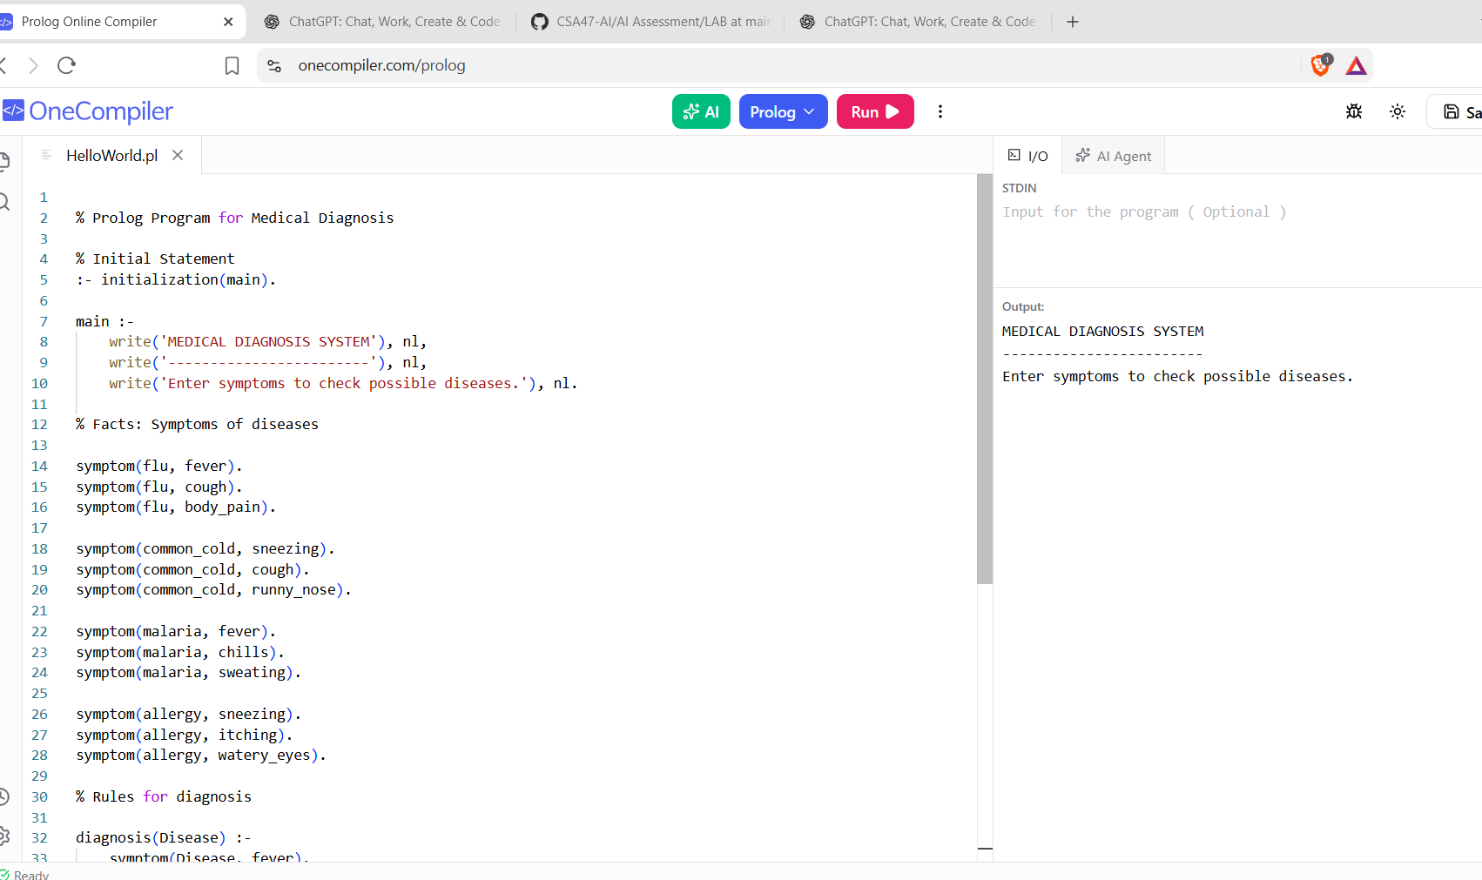

RESULTS:
The program identifies possible diseases based on the symptoms provided.

